SENSELab - THERMOTEST™
Thermal exposure software.

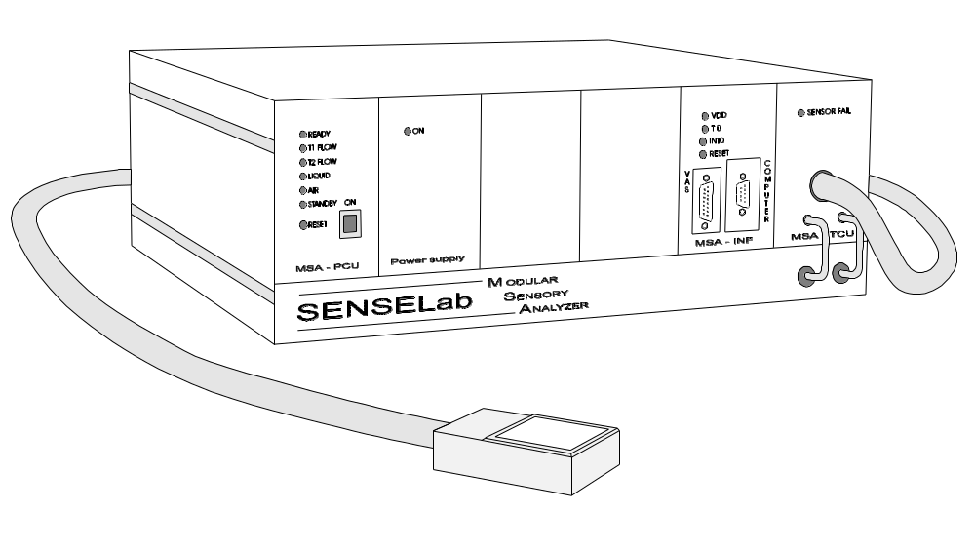

USER’s MANUAL

Ver 01 – 2000-03-13

SOMEDIC Sales AB, Box 194, S-242 22 Hörby, SWEDEN.
Phone: +46-415-16550, fax: +46-415-16560
E.mail: info@somedic.com

TABLE OF CONTENTS Page

General information 3

Applicability of manual 3
Manufacturers information 3
Year 2000 compatibility 3
Trade marks 3
Copyright 4

Introduction 5

Intended use 5
Prerequisites 5

Installation 6

From floppy disk 6
From CD 6

Use 7

Initial action 7
Start screen 7
Defining pulses 8
Adding pulses to a sequence 10
Add a new sequence 11
Using pulses or step in a sequence 12
Stimulation 13
Single pulse stimulation 14
Setting the COM-port 14

LIST OF ILLUSTRATIONS:

Figure Description

1 Start screen for EXPOSURE program. 7
2 Control, then settings to edit a pulse sequence. 8
3 Settings folders. 8
4 Pulse settings folder. 9
5 Defining new pulse. 9
6 Add new pulse. 10
7 Sequence settings folder. 10
8 Adding pulses to a sequence. 11
9 Creating a new sequence. 11
10 Pulses in a sequence. 12
11 Pulses making steps in a sequence. 12
12 Start screen, ready to start a sequence. 13
13 Start screen during slope- left, during timing interval - right. 13
14 Start screen for single pulses. 14
15 Com Port setting. 14
GENERAL INFORMATION:

APPLICABILITY OF MANUAL

This manual applies to SENSELab Thermal Exposure software, version number 1.

MANUFACTURERS INFORMATION

In case You need to contact us, for obtaining information further to what is found in this manual, with comments or suggestions regarding our products, or for any other reason, then please contact us by mail at the following address:

SOMEDIC Sales AB
Box 194
S-242 22 HÖRBY
SWEDEN

Or use any of the following:

Phone: int+46 415 16550

Fax: int+46 415 16560
E-Mail: info@somedic.com

YEAR 2000 COMPLIANCE

The Thermal Exposure software requires Windows 95/98 for it’s operation and is written in Visual Basic, using Microsoft Office 97 professional with Word, Excel and Access for report generation, calculations and data base handling. All these software products are fully Year 2000 compliant.

TRADE MARKS

Trade mark/name Owner

SENSELAB SOMEDIC Sales AB, SWEDEN.
IBM International Business Machines, Inc, USA
Windows 95/98 Microsoft Corporation, USA.
Word/Excel/Access Microsoft Corporation, USA.

Other product and company names listed are trademarks or trade names of their respective companies.

COPYRIGHT

This manual is written to guide and help in the use of the MSA system. As such SOMEDIC Sales AB has developed it and international copyright laws protect it. Under the copyright laws, this publication may not be reproduced or transmitted in any form, electronic or mechanical, including photocopying, recording, storing in an information retrieval system, or translating, in whole or in part, without the prior written consent of SOMEDIC Sales AB. Indispite of the copyright protection, any owner of a MSA system is granted the rights to freely copy and use the material in this manual, as long as a reference is made to the source.

INTRODUCTION:

INTENDED USE

This software shall be used together with the SOMEDIC SENSELab MSA Thermal Stimulator, for the generation of single thermal pulses as well as complex patterns of time-varying thermal stimuli. These stimuli may be anywhere in the full range of the Thermal Stimulator and the user has to be responsible for not exposing any subject to a thermal energy that could create thermal effects exceeding the planned level of exposure for the subject.

 WARNING:

Please note that temperature levels higher than normal human skin temperature under certain conditions can create damage to skin exposed to such temperature. In particular it is known that 7 minutes of exposure at 46 degree can induce a first-degree burn. Higher temperatures may create damage at much shorter exposure times and lower temperatures may create damage after longer exposure time, although large individual variations may exist.

PREREQUISITES

The SENSELab MoL (Method of Limit, thermal threshold measurement) program shall normally be present on the computer that shall hold the exposure program. The system shall also be properly calibrated, as reflected by a properly installed SENSELAB.INI file.

INSTALLATION

The exposure program may be delivered as either a floppy disk or a CD. The floppy disk contains the necessary files to install the Exposure program on a computer that already has the SENSELab MoL program. The CD contains all information to create an installation, which will work without the MoL program.

Installation from floppy disk:

For this installation, you will need knowledge of how to copy files from one directory, to another and how to create a short cut to a program. If you are in doubt that you have this knowledge, then please seek assistance from your computer department or your supplier of this program.
Insert the floppy disk (FD) in your diskette station. The diskette station is normally defined as A:, if yours is defined as B:, then change A: to B: in the following text.

Open A: where you shall find the following files:

EXPOSURE.exe
EXPOSURE.mdb
Expos_user01.doc

Now open your hard disk assumed to be C:, and go through the directory tree to where you have the C:\WINDOWS\SENSE101 and open this folder. Here Windows may not immedeately allow you to get to the Windows catalog, but you may have to acknowledge that you really want to have access to the Windows folder before you can select the SENSE101 folder. Now copy the EXPOSURE.mdb (database) from A: to the C:\WINDOWS\SENSE101 catalog SENSE101 folder. (Copy is done by marking the file, then holding down the Ctrl tangent of the keyboard and dragging the file to it’s new location.).
Now go back in the directory tree of C: to the root (C:\) and go up again to C:\SENSE101 (or, if you during installation of SENSELab MoL decided to place that program at another catalog than the standard, then you need to select this folder) and open the folder. Please also note that although it has the same name as the previous folder for storage of the database, it has a different location and is NOT the same folder.
Copy EXPOSURE.EXE from A: to the SENSE101 folder). You may also copy this manual to this directory (copy Expos_user01.doc from A:). or you may prefer to keep it only on the FD.
The installation is finished as you create a short cut to the EXPOSURE.exe program and place this short cut on the desktop.

Installation from CD:

This installation is fully automatic and you just need to accept the alternatives presented on the screen.

USE

Initial actions

Turn on the MSA and verify that no alarm circuits of the MSA is activated before starting its use. In this way fluid levels and the thermode condition is verified.

Program use

Click on the EXPOSURE icon. From the window that opens see Figure 1, you can immediately start to generate pulses and sequences of pulses from the list of pre-programmed examples. If you like to generate single pulses, defined at the time of stimulation, you click on Single pulse in the centre field for Mode selection. Or you may click on sequence, to get access to the predefined pulses and sequences of pulses.

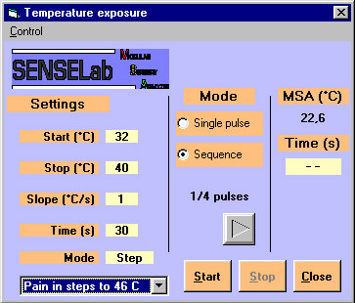

Figure 1: Start screen for EXPOSURE program.

To design your own pre-programmed pulses, or sequences of pulses, click in the Task bar (upper left portion of screen) on Control, then settings. You may also press directly on F2, see figure 2.

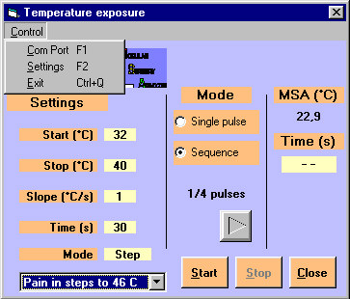

Figure 2: Control, then settings to edit a pulse sequence.

You will now have access to two folders, as seen in figure 3.

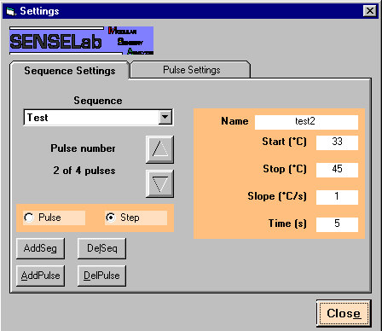

Figure 3: Settings folders.

Choose the folder “Pulse settings” and the window will change to as seen in figure 4.

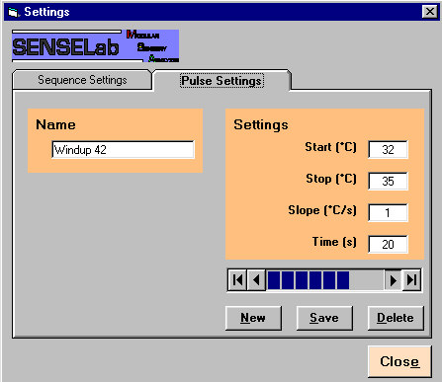

Figure 4: Pulse settings folder.

Here you can scan through the already pre-programmed pulses, by clicking on the bar at lower right. If there is no pulse that match your requirements, then you create a new, see figure 5.

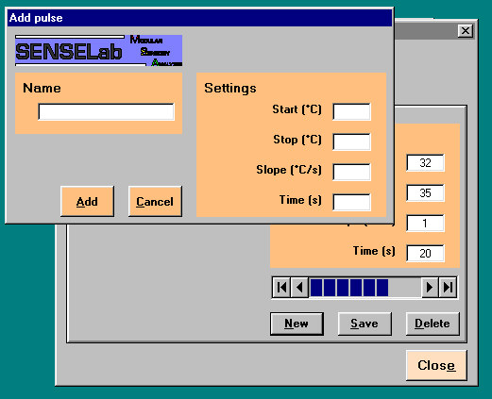

Figure 5: Defining new pulse.
Fill in the fields with name and settings then click on the Add button, see figure 6. The pulse will be added at the end of the list of pulses.

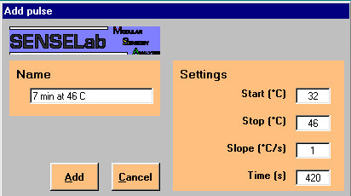

Figure 6: Add new pulse.

To be able to use the pulse you just defined, you need to include it in an existing sequence, or set up a new sequence (with anything from 1 to a very large number of pulses, or repetitions of the same set of pulses). Open the sequence setting folder, see figure 7.

Figure 7: Sequence settings folder.

To include the pulse in an existing sequence, select the sequence from the pull-down menu, then choose the right position for the pulse in the sequence by clicking the up and down arrows until you are at the pulse number that shall be before the new pulse, then click Add pulse.

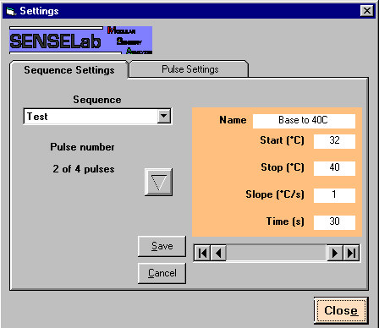

Figure 8: Adding pulses to a sequence.

Select the pulse to add by the rollbar, as seen in figure 8. The definitions for the pulses are shown as the rollbar is toggled. To select a pulse, click on Save. Continue with more pulses, if needed.

To create a new sequence, click on Add Seq. and type in the name of the new sequence, then OK. See figure 9.

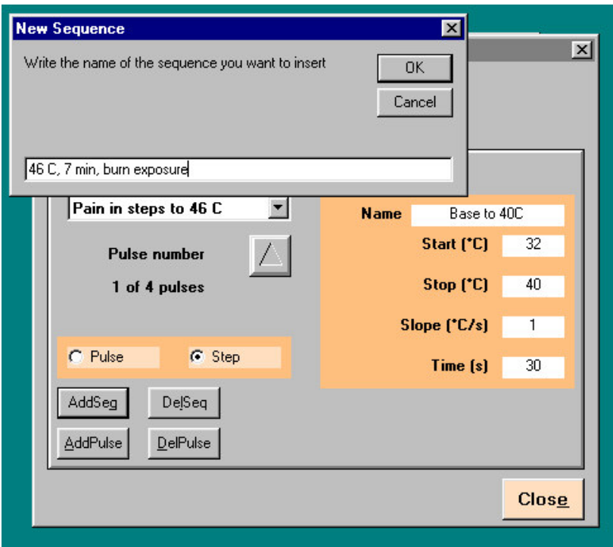

Figure 9: Creating a new sequence.
A new Sequence folder opens, with no pulses. Select Add pulse and add any number of pulses to the sequence.

When setting up a sequence, the transition between the pulses in the sequence can be defined as pulse, or step. This is defined by clicking in the appropriate marker Pulse or Step (found just above the buttons for adding pulses and sequences).
Pulse should be interpreted such that each individual pulse is an isolated event, with its individual temperature and timing characteristics. After the pulse, the control is given over to the operator to select among the available pulses and to start a new pulse or stop the sequence. See figure 10.

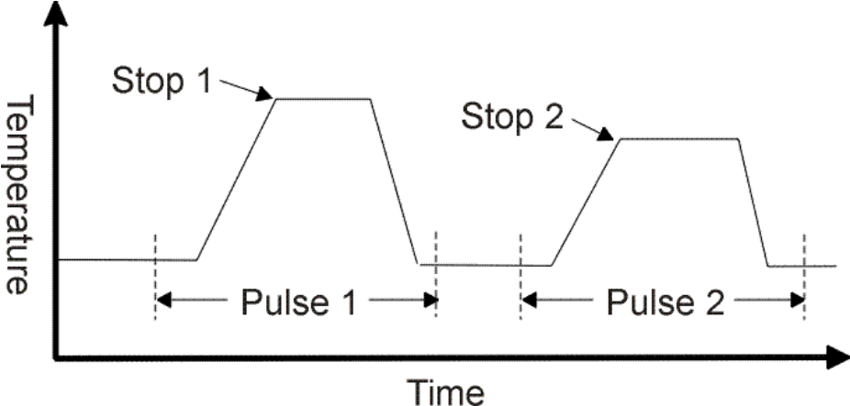

Figure 10: Pulses in a sequence.

By selecting step, the pulses in the sequence is put in a chain, such that after the time of one pulse has terminated, the next pulse will take over, without the temperature returning to the baseline. The temperature will directly go from the stop temperature of the preceding pulse, with the slope defined by the present pulse, to the stop temperature of the present pulse. There the temperature will reside for the defined time, when control is given over to the next pulse, and so on until the end of the sequence. See figure 11.

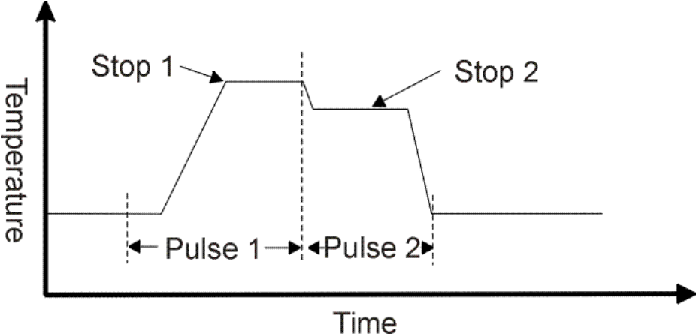

Figure 11: Pulses making steps in a sequence.

Press Close after that all editing of the new sequence is done. Program will now return to the Start screen.
To stimulate, check that the MSA is ready, then choose the proper sequence and press Start, see figure 12.

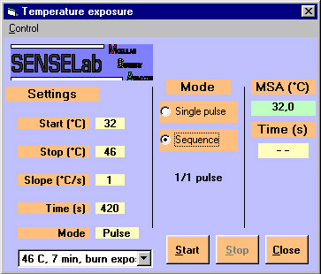

Figure 12: Start screen, ready to start a sequence.

The temperature will start to change from the start temperature to the stop temperature, with the selected slope. When the selected stop temperature is reached; the Time will start to count, until the set interval has been counted. Then the temperature will return to the start temperature of the next pulse or to the temperature of the next step (next stop temperature).

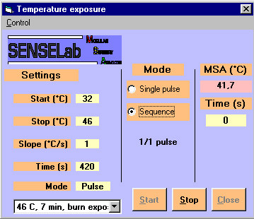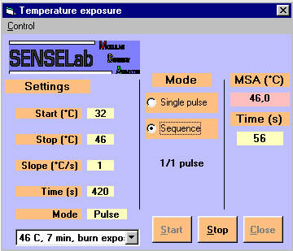

Figure 13: Start screen during slope- left, during timing interval - right.

If, during thermal stimulation, the sequence needs to be interrupted, clicking on Stop in the Start screen, or pressing the patient push-button returns the temperature to the start temperature.

As an alternative to using a sequence, the program may be set to work with pulses that are defined at the time of stimulation. Then mark Single pulse in the centre Mode field. See figure 14.

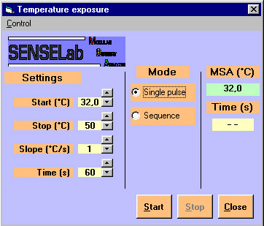

Figure 14: Start screen for single pulses.

In case that the Exposure program has no control over the MSA, then it may be set for the wrong COM-port. Check the settings of the COM-port for the SENSELab MoL software (assuming that this program works properly) and set the Exposure program for the same COM-port.
Click in the Start screen on Control, then Com Port to have access to the window for setting the COM-port, see figure 15.

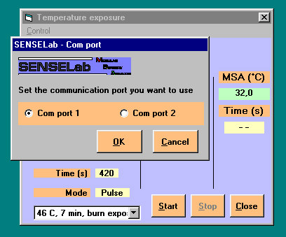

Figure 15: COM Port setting.

